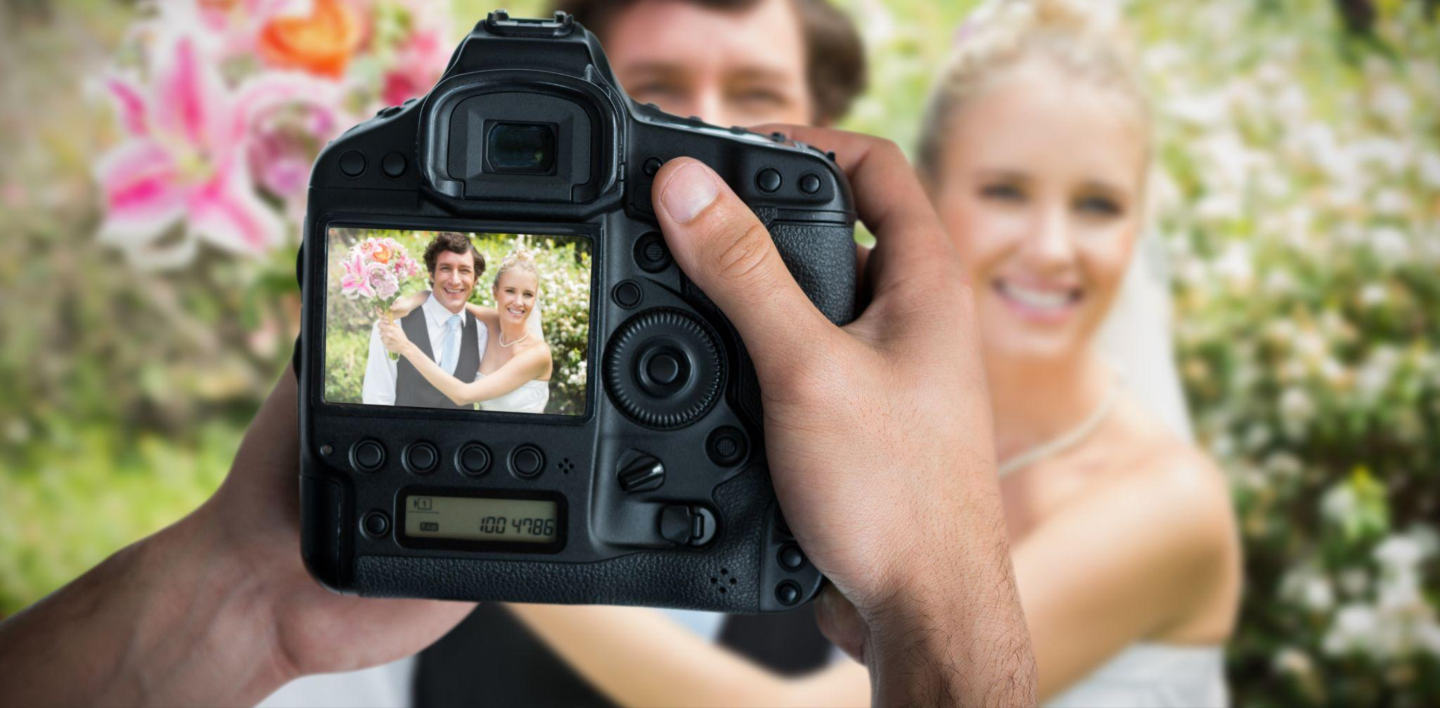Photo by Adobe Stock

Why Professional Wedding Photography is the Way to Go
Your wedding day is one of the most important days of your life, and you want to capture every moment of it in the most beautiful way possible. While it may be tempting to have a friend or family member take the photos, investing in a professional photographer will ensure that every moment is captured with quality and creativity. Not only will it take the pressure off of you and your loved ones, but the lasting value of professional photography is unmatched.

In this article, courtesy of Bluebird Cottage Wedding Venue & Event Center, we'll explore the benefits of hiring a professional photographer for your wedding.

From Lenses to Lighting
Professional photographers invest in high-quality equipment that ensures the best possible image quality. Cameras, lenses, lighting equipment, and editing software are all crucial components of professional photography. Compared to a friend or family member, a professional photographer has access to equipment and tools that are far beyond what the average person may own, which can make a significant difference in the quality of your wedding photos.

Love in Focus
Professional photographers have an eye for creativity and can offer suggestions for unique shots and poses that you may have never considered. They'll know how to use the environment around you and create stunning images that highlight your love story. With their guidance, you can ensure that your wedding photos are one-of-a-kind and truly reflective of your personalities.

From Mind's Eye to Reality
Experience is one of the key advantages of working with a professional photographer. Professional photographers have years of experience in capturing weddings and understand how to stage a shot. They'll know the right angles, lighting, and composition to create stunning images. They'll also have an understanding of the wedding timeline and when certain photos need to be taken to ensure that nothing is overlooked.

Take a Deep Breath and Relax on Your Big Day
Your wedding day can be hectic, and worrying about the photography shouldn't be an added stress. Hiring a professional photographer can alleviate that stress and help you enjoy your big day without worrying about capturing every moment. A professional photographer will know how to manage their time, work with various conditions, and capture those spontaneous, candid moments that make your wedding unique.

From Click to Print: Put Your Images to Work
When it comes to capturing memories, professional photography is the gold standard. But what about after the shoot? With Adobe Express Products, making the most of your photos has never been easier. Regardless of whether you have design experience! Here's a rundown of some of our favorite tools::

- Take a Journey Down Memory Lane: Want to create a video montage of your wedding photos set to your special song? The Adobe Express photo video maker makes it easy. Import your photos and music, choose from a variety of transition styles and visual effects, and create a beautiful video that you'll treasure for years to come.
- Express Your Gratitude: After your big day, show your guests how much you appreciate their support with custom-designed thank you notes. An Adobe Express wedding thank you card template lets you create custom cards with your wedding photos and a heartfelt message. With a variety of templates and editing options, you can design a card that's as unique as your love story.
- Falling in Love All Over Again: Turn a collection of wedding photos into a stunning slideshow in just a few clicks using the Adobe Express slideshow maker. Simply import your photos into the app, select your desired music and transition styles, and voila! You'll have a beautiful slideshow to share with loved ones.
- Seasons Greetings: A holiday card presents the perfect opportunity to share some of your favorite wedding snaps. Check out the Adobe Express holiday card creator to design a special greeting this season. Choose from a variety of pre-designed templates, add your own photos and text, and create a one-of-a-kind card that captures the spirit of the season.

In Conclusion
Investing in professional wedding photography is invaluable because it captures the most cherished and beautiful moments of your special day. Professionals bring their expertise in utilizing lighting, lenses, and editing to create stunning, timeless images that breathe life into your memories. With a professional behind the lens, couples can relax and fully immerse themselves in their day knowing that every moment will be captured beautifully. Don't miss out on the opportunity to preserve your memories for a lifetime, and make professional wedding photography a top priority.

Don't wait to book your photography services for your special day. Contact Bluebird Cottage Wedding Venue & Event Center today!

